Teacher Information Pack
Facilitated School Visits

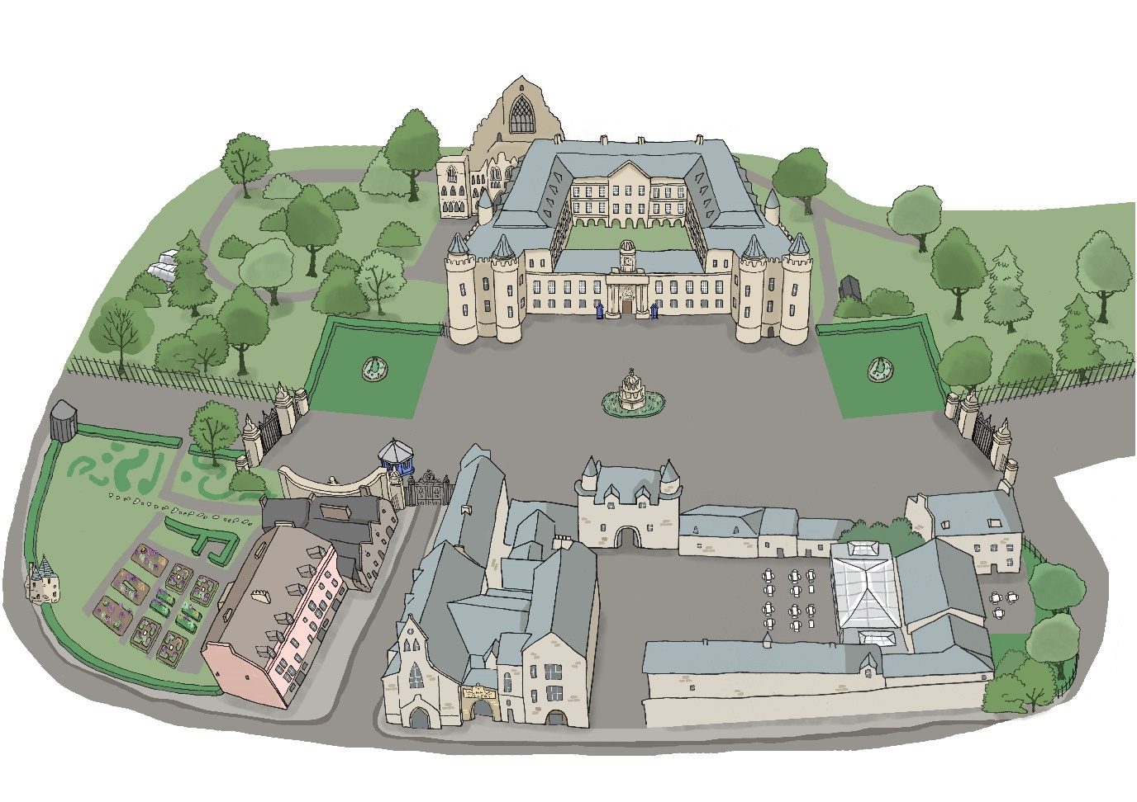

We are looking forward to welcoming you to the Palace of Holyroodhouse. This pack is designed to give you all the practical information you need to book and plan an enjoyable and safe visit.
Contents

Introduction
About the Palace of Holyroodhouse | 2
About Royal Collection Trust | 2
Our nursery and school programme | 2
Our nursery and school programme prices | 2
Schools access scheme | 3
Booking your visit
How to book your visit | 4
Before your visit
Health and safety | 5
Risk assessment | 5
Complimentary planning visit  Security | 5  5
Pre-visit resources | 6
Pre-visit SEND resources | 6
Your visit
Getting to the Palace | 7
Arriving at the Palace | 7
Abbey Strand Centre | 7
Your facilitated sessions | 8
Visiting the Palace – school visit guidelines | 8
Lunch | 8
Feedback | 8
After your visit
Post-visit resources | 9
Keep in touch and stay involved | 9
Appendix
Palace of Holyroodhouse map
No photography sign

Introduction

About the Palace of Holyroodhouse
The Palace of Holyroodhouse is His Majesty The King's official residence in Scotland. It has been the scene of important and dramatic events across the centuries involving Robert the Bruce, Mary, Queen of Scots, Bonnie Prince Charlie, Queen Victoria, and more.

About Royal Collection Trust
Royal Collection Trust looks after the Royal Collection, one of the most important art collections in the world and manages the public opening of the official residences of His Majesty The King. Through our work, from exhibitions and learning programmes to publications and retail products, we aim to ensure that the Royal Collection and Palaces are valued and enjoyed by everyone

Our nursery and school programme
A visit to the Palace provides a memorable setting for learning and unique opportunities to meet Experiences and Outcomes of the Curriculum for Excellence. Our expert-led interactive sessions are suitable for pupils in nursery, primary and secondary school. To find out more about our nursery and school programme visit: https://www.rct.uk/discover/school-visits

Our nursery and school programme prices
Our Palace school sessions are £3 per pupil. Children in P1 and below are free of charge.
One teacher or adult helper is admitted free of charge at the following ratios:
- Early Years – P1 - 1 adult: 3 pupils
- P2 – P4 - 1 adult: 6 pupils
- P5 and above - 1 adult: 10 pupils
Additional teachers or adult helpers above this ratio to support SEND pupils are admitted free of charge.

Schools Access Scheme
Royal Collection Trust is a registered charity. Income from ticket sales, including school groups, contributes directly to the care and conservation of the Royal Collection.

One of Royal Collection Trust's Charitable Aims is to broaden and increase access for the nation. We are therefore, on occasion, able to coordinate complimentary admission to The Official Residences of The King and to The Queen’s Galleries in order to ensure visits are possible for schools working for and with economically disadvantaged pupils. To find out more and to apply visit https://www.rct.uk/schools/teacher-information-documents

Booking your visit

How to book your visit
Once you have decided on which session is most suitable for your class would the next thing to do is to book your visit. To book your visit please consider the following and then contact the Learning Booking Team:
- The session most suitable for your class
- Preferred date of visit and possible alternatives
- Preferred arrival time
- Whether you would like to book a learning space for your class to eat lunch in
- Numbers of children and supervising adults
- Details to support SEND pupils
- Contact Learning Booking Team:
Learning Bookings Team
Ticket Sales and Information Office
Buckingham Palace
London SW1A 1AA
T. (+44) (0)303 123 7323
F. (+44) (0)20 7930 9625
learning@rct.uk
Once you have made your booking you will receive a reservation letter. This reservation letter will confirm details of your booking including the session you have chosen, session times and lunch times and numbers of pupils and adults booked. Please read this carefully and if anything is incorrect contact the Learning Bookings Team. If your booking requires payment, the letter will confirm the date by which full payment must be received. All bookings are made subject to our terms and conditions. To see these please visit https://www.rct.uk/schools/teacher-information-documents

Before your visit

Health and safety
The Royal Household is committed to the principle of ensuring the health, safety and welfare of the general public within the royal residences. Under the guidance of our Fire, Health and Safety Branch, an established policy sets out staff and management responsibilities for all areas of activity and for the conduct of risk assessments.

The following statements summarise the main provisions of this policy:

- All areas at The Palace of Holyroodhouse, open for visitor admissions have been assessed both for compliance with current Health and Safety requirements and with the provisions of the Equality Act (2010).
- Regular inspections by operational, maintenance, and health and safety staff ensure that high levels of safety and visitor service are maintained. Cleaning and maintenance staff are available at all times during public opening hours, together with supervisory staff under the direction of a Duty Manager.
- Emergency procedures are published for all public areas, and staff undertake regular fire and evacuation training. All wardens are in radio contact.
- Trained first aid staff are available, supported by a permanently staffed fire surveillance team who are able to provide strong first aid cover
.
Risk assessments!

The Royal Household has undertaken workplace risk assessments to cover all areas of operation, with a particular focus on visitor access and they are reviewed on a regular basis.

In order for you to carry out risk assessments specific to your class we offer complimentary planning visit tickets.

Security
On arrival your belongings will be subject to a bag check. Try to bring as little as possible with you as it will help you to get through this process more quickly. For full information, please visit Practical Information for visiting the Palace of Holyroodhouse (rct.uk) .

Complementary planning visit
Once you have booked your visit you are entitled to 2 complimentary tickets to the Palace so you can undertake a planning visit. During your planning visit it might be possible to meet with a member of the Learning Team or see the Abbey Strand Centre. To book your complementary planning visit please contact the Learning Bookings Team.
Pre-visit resources
We have a range of resource available to help your class prepare for their visit. To explore these visit https://www.rct.uk/discover/school-resources

Pre-visit SEND resources
We also have resources to support SEND pupils including a visual story. To see these please visit https://www.rct.uk/visit/palace-of-holyroodhouse.

Your visit

Getting to the Palace
By coach and bus | Bus number 35 stops near the Palace.  Limited free coach parking is available adjacent to the Palace on the North Approach. Alternative pay-and-display coach parking is available on nearby Regent Road.
By train | Edinburgh Waverley. The Palace is a 15 minute walk from the station. Visit National Rail Enquiries for times and fares.
By tram | The nearest tram stop is York Place. The Palace is a 20 minute walk from the station. Visit Edinburgh Trams for times and fares.

Arriving at the Palace
Please arrive promptly for your session start time. If you arrive early, you are welcome to enjoy the Physic Garden. If you are running more than 15 minutes late, please call the Learning Bookings Team.

When you arrive at The Palace of Holyroodhouse please come directly to the Abbey Strand Centre where a member of the Learning Team will be waiting to greet you. They will then welcome your class, confirm numbers and times, and ask you about your classes prior knowledge regarding your chosen session.

Abbey Strand Centre
On entering the Abbey Strand Centre your group will be directed to our cloak room where they can leave coats, bags and lunch boxes. Your group are then welcome to use our lavatories.

Your facilitated session
Many of our sessions start with an introduction and workshop in one of our learning spaces. After this your group are welcome to use our lavatories before their visit to the Palace. Please be aware there are no lavatories within the Palace.

Visiting the Palace
In order that everyone has a safe and enjoyable visit to the Palace, we ask all teachers and adults helpers to read the following guidelines:
School Visit Guidelines

- During the visit, teachers and adult helpers are responsible for pupils’ safety and behavior.
- Teachers and adult helpers must stay with the class at all times.
- Teachers and adult helpers may be asked to support pupils with completing activities during the session.
- Pupils are kindly asked not to run in the Palace. Teachers and adult helpers are asked to manage this.
- Pupils are kindly asked not to get too close or to touch paintings, objects or furniture. Teachers and adult helpers are asked to manage this.
- In the case of an emergency teachers, adult helpers and pupils are asked to follow the instructions of members of the Learning Team, Security Team and Visitor Services Team (Wardens).
- Photography is not permitted within the Palace but is permitted in the exterior areas and Abbey Strand Centre. Please be aware that visitors to the Palace may try to take photographs of pupils. Wardens are vigilant and will speak to visitors if this occurs and ensure photographs are deleted. If you witness this happening before a Warden please speak to the member of the Learning Team facilitating your session or a Warden so they can speak to the visitor and ensure photographs are deleted.

Lunch
If you have booked a learning space for lunch, you will be directed to this at the time detailed on your reservation letter. We ask that during this time teachers and adult helpers stay with the class and supervise visits to the toilets. A member of the Learning Team will remain in Abbey Strand if you require assistance and in the case of an emergency. We ask that you adhere to your 30 minute allocation and on leaving the learning space to ensure the learning space is clean and tidy and to take all rubbish and recycling with you.

Feedback
After your session you will receive a feedback form. We would be grateful if you were able to complete this before you leave Abbey Strand or back at school. Your feedback helps us improve our nursery and school programme.

After your visit

Post-visit resources
We have a range of resource available to help your class continue their learning after their visit. To explore these visit https://www.rct.uk/discover/school-resources

Keep in touch and stay involved
We love to see and hear about your visit to the Palace and the learning it has inspired back in the classroom. If you would like to share any of this with us through social media please mention @RCT or use the hashtag #HolyroodPalace.
You can also stay in touch by subscribing to our school e-mail updates. Each term you will receive the latest news and details of upcoming school sessions, resources and teachers events. To sign up visit https://www.rct.uk/schools/sign-up-to-our-school-e-mail-updates

Palace of Holyroodhouse Map
1 | North Approach –  Coach Park
2 | Abbey Strand Centre
3 | Palace of Holyroodhouse
4 | Gift Shop
5 | Physic Garden
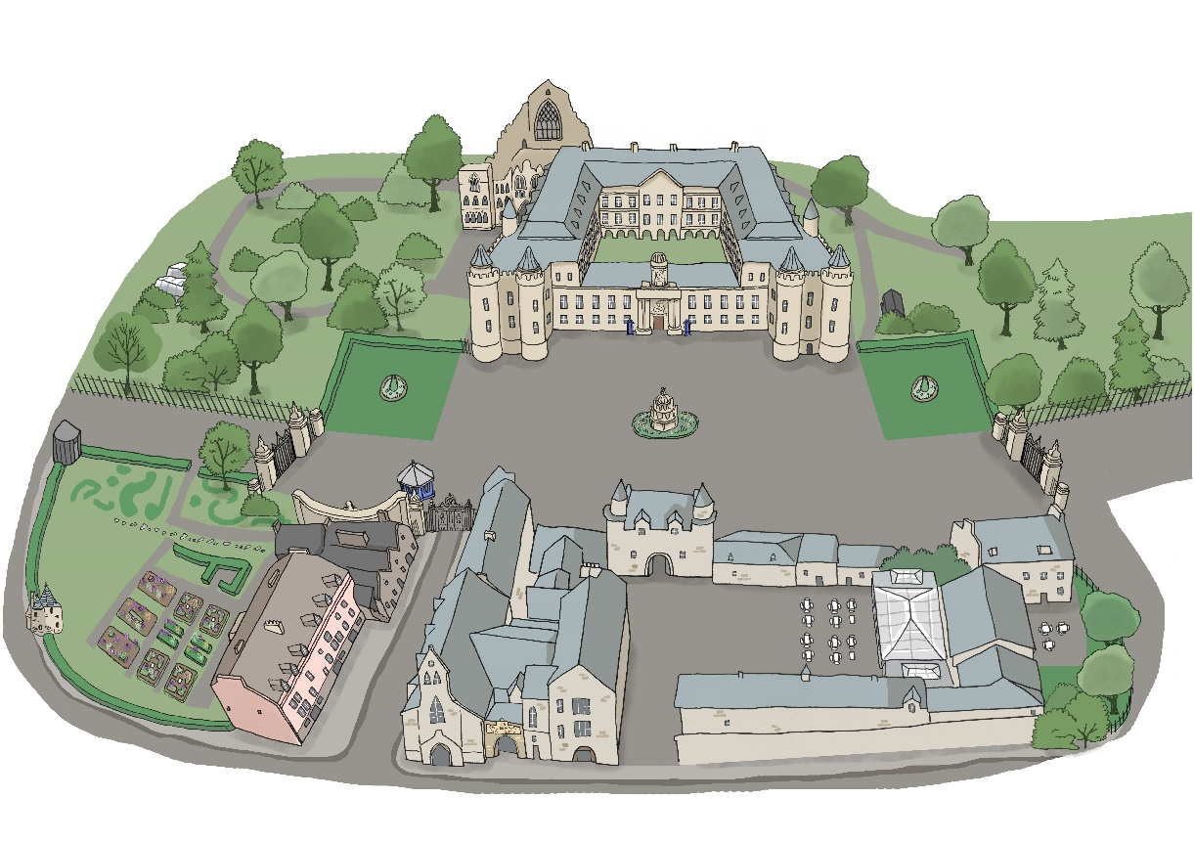
5
4
3
22
1
No photography

